

JOB INFORMATION PACK

Facilities Manager (Fixed Term)

Fixed term to April 2025

 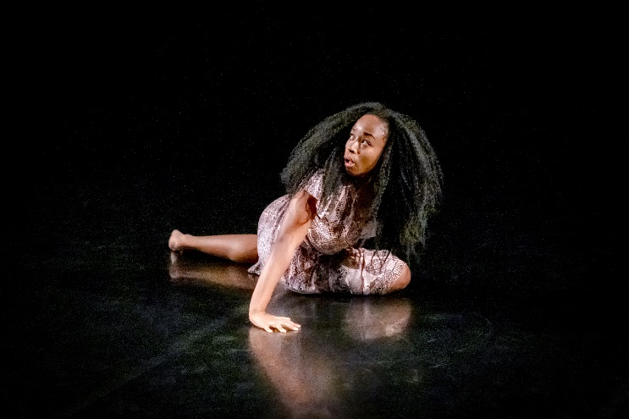

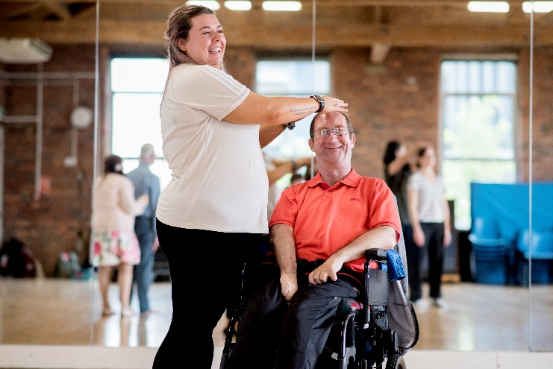 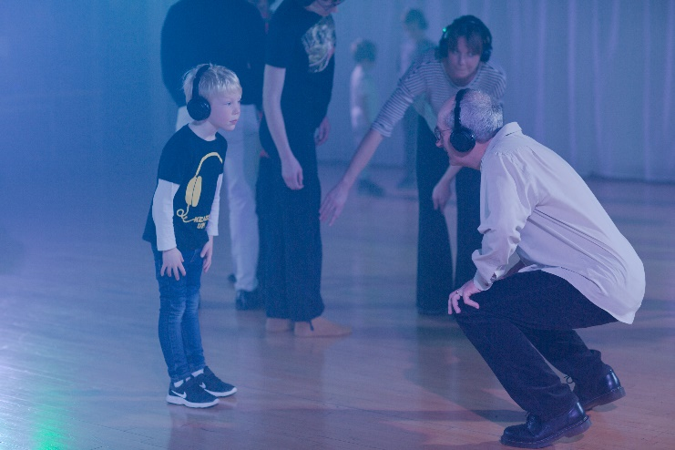

*Images Clockwise from top left: Saturday Superstars Youth Dance Classes © Sara Teresa, Alethia Antonia performing at No Dress Code © Ant Robling, Audience members interact at H2’s Strangers & Others at Encounters Festival © Sara Teresa, Leaps & Bounds group for adults with learning disabilities © Camilla Greenwell (these are just a few of the activities which take place in our building)*

Dear Applicant,

Do you have experience of buildings management? Are you looking for a fixed term contract, which will make a huge difference to an arts charity in the heart of Leeds?

# Yorkshire Dance are looking for someone to lead facilities management and project manage our full building audit from November to April 2025.

This is a great opportunity to gain a rounded experience of building management, as maternity cover for our Operations Manager, and lead on a time bound project. You will be responsible for related procurement and implementing and maintaining the building’s policies and health and safety obligations while in post.

# You will be based in our city-centre building which hosts our offices, studio spaces and regular performances, giving you a real insight and experience of working in a lively performance venue. While the role is ideally for a full-time candidate, we are open to conversations around flexible work patterns, including: Part-time and job-share, etc.

Each year Yorkshire Dance supports 200 dance artists, hosts 4 dance festivals (audience of 3,500), runs 4 sub-regional dance networks and delivers 1,500 weekly community dance sessions (1,500 participants). Dance sessions take place in our studios, in community centres and care homes throughout Leeds and Bradford. You can find out more about our current programmes on our [website](https://yorkshiredance.com/) and social media.

Yorkshire Dance offers a supportive work environment, in addition to a range of benefits which generally include:

* Hybrid working including time in the office and at home (if required).
* Training opportunities both relevant to your role and the organisation (e.g. the full staff team have recently undertaken training in anti-racism, Dementia Awareness and Trans Awareness)
* Pension scheme
* An annual Go See Fund to purchase tickets for dance performances (and complimentary tickets for most performances run by Yorkshire Dance), or to partake in dance classes
* Maternity and sickness pay in line with our policies
* Tech scheme
* Cycle to work scheme
* Bus to Work scheme (discounts on First Bus and Trans Dev)
* Eye care

If you would like to have an informal chat about the post, or have any queries, please contact me on 0113 243 9867 or [johawkes@yorkshiredance.com](mailto:johawkes@yorkshiredance.com).

Thank you for your interest, and I look forward to receiving your application.

Yours faithfully

**Jo Hawkes**

Executive Director

**Yorkshire Dance**

**Mission**

Yorkshire Dance works through dance to create happiness, health, connection and change. We create opportunities for people of all ages, backgrounds and abilities to see, make and take part in high quality dance. [Meet the team here.](https://yorkshiredance.com/about/who-we-are/)

**Our Values & How we work**

We are creative

We are curious

We are inclusive

We are joyful

We care

Underpinning this plan is our commitment to being an ethnical organisation.

We commit to fair pay and fair working practices for all staff and freelancers.

We commit to increasing our environmental sustainability and to use our platform to increase public awareness of the Climate Emergency.

We apply co-design and co-creation principles to all our activity, from project planning to the creative process wherever possible and appropriate.

We are committed to work in partnership with health, sport, community, local authority and arts partners to increase impact and relevance of our work.

Facilities Manager - Job Profile

**Main purpose of the job:**

The post holder will be responsible for the practical oversight of Yorkshire Dance’s building and related operations to ensure the organisation complies with all current legislation relating to site safety and management. To promote and participate in achieving the most efficient and economic use of the premises, facilities, plant and equipment.

The post holder will lead on a full building audit of the premises, putting together a fully costed preventative maintenance plan which will aid the smooth running of the home of Yorkshire Dance for years to come.

**Position in the organisation:**

## The post holder is a member of the senior management team and will report to the Executive Director. The post holder will line manage the Operations Assistant, Front of House Team and Site Supervisor.

**Scope of the job:**

* Manage the day-to-day building operations of Yorkshire Dance.
* Oversee all hires of Yorkshire Dance facilities and lead on excellence in customer service (supported by the Operations Assistant).
* Manage budgets relating to building maintenance, cleaning, health and safety, equipment and refreshments.
* Alongside the Operations team, be a key point of contact for all building users: tenants, artists, community participants, visitors and hirers. Manage relationships with hirers, contractors, suppliers, and other building users.
* Undertake and oversee planned and emergency maintenance (with support from the Site Supervisor) and manage and implement all aspects of the building maintenance plan, ensuring full legal compliance.
* Lead on a full building maintenance audit and plan for the time in post.
* Provide technical (AV) and logistical support for our artistic and community participation programmes and building users.
* Work with the Executive Director & Yorkshire Dance’s Green Team on Yorkshire Dance’s endeavour to be environmentally friendly and responsive to the climate crisis.
* Be responsible for various facets in relation to building operations and implement company policies relating to Health & Safety, including writing risk assessments.
* Recruit and line-manage the Operations Assistant, Site Supervisor and Front of House Team.
* Act as primary key holder for the building and be the first point of contact for contracted security services in an emergency.
* With the Executive Director, maintain relationship with tenants and commercial hirers. Coordinate with the Finance Assistant to ensure timely payments and chasing outstanding debts.

DUTIES AND KEY RESPONSIBILITIES

**Building Operations (30%)**

* To ensure the smooth day-to-day running of activities in the building.
* To develop, implement and maintain high standards of customer care and maintain excellent relationships with tenants, artists, hirers, visitors and other building users.
* To provide operational and technical support for Yorkshire Dance internal and external events and to building users.
* To plan and organise Yorkshire Dance equipment and resources and take responsibility for all equipment/stock and materials on the premises to ensure best possible use.
* To be responsible for training Yorkshire Dance staff, tenants and regular building users in all building functions, security procedures and Health and Safety (including being or becoming IOSH certified yourself).
* To support procurement of new equipment and furnishings.
* To be the holder of a personal licence for the sale of alcohol and fulfil the role of Designated Premises Supervisor in respect of Leeds City Council licensing requirements.
* To be the lead First Aider and Fire Warden and undertake related training, if required.
* To undertake any related tasks that may be deemed necessary from time to time.
* Work with the Executive Director to review staff capacity and our hybrid working pattern rota to ensure the building has the minimum number of staff at all times.

**Building Maintenance (30%)**

* To lead on a full building audit and introduce a preventative maintenance plan to ensure the premises can run at its best.
* To take the lead on compliance with all Health and Safety, licensing and fire regulations operational within the building at all times.
* To establish and manage a programme to ensure the day-to-day, cyclical and long-term maintenance of the Yorkshire Dance premises (building and grounds) and equipment.
* To work with the Site Supervisor to use basic practical skills to provide immediate solutions for emergency building matters (e.g. security, plumbing, phone system, decoration, lighting, IT, etc.).
* To plan and implement essential central services including bi-weekly emergency light testing, security, cleaning, telecoms, utility supplies, waste disposal and recycling.
* Be aware of the location of essential services and maintain a detailed plan showing the location of these.
* Work with the Executive Director & Trustees on capital developments for the building when required.
* Work with professional architects and project managers on discreet refurbishment projects.
* Support the Executive Director with sustainable management of the building and business operations.
* Report to Julie’s Bicycle (training provided) in relation to the organisation’s carbon footprint based on utilities usage.

**Income Generation (20%)**

* To be responsible for the booking, letting and hiring of Yorkshire Dance space and facilities and arrange and prepare facilities in accordance with clients’ stated needs.
* Support the Operations Assistant to manage the evening class programme.
* To be responsible for merchandise and bar sales and management of stock.
* Support the Head of Marketing & Development to market Yorkshire Dance services and activities within the building.
* To oversee and undertake daily cashing up, monthly banking, petty cash distribution and manage other related banking procedures for the Front of House team.

**Managing Operations Team (20%)**

* To ensure adequate and appropriate staff cover on Front of House, including for all public events within the building.
* To induct and train new members of the Front of House staff team on all aspects of their role, including Salesforce.
* To support and supervise the Operations Assistant and Site Supervisor.
* To work closely with the Company Administrator.

**General duties applicable to all Yorkshire Dance contracted staff**

The particular duties and responsibilities attached to posts may vary from time to time without changing the general character of the duties of the level of responsibility entailed. All Yorkshire Dance staff are expected to:

* Undertake all activities in compliance with Yorkshire Dance’s policies and procedures with particular reference to equality and health and safety.
* Promote the activities, products and values of Yorkshire Dance.
* To participate in the staff review and development scheme, and undertake continued professional development activities as identified.
* To be a key holder and to lock and unlock the building on departure and arrival as required.

**Terms and Conditions**

Salary: Full-time equivalent of £26,000 per annum

Pension: Where eligible, auto-enrolment in company pension scheme

Period of contract: Fixed term to April 2025.

Hours of work: 37.5 hours per week including evening and weekend work as required (no overtime is payable, but time off in lieu may be given)

Annual Leave: 25 days plus statutory and bank holidays pro-rata.

Probation period: 1 month

Notice period: 1 month

Right to work: The candidate would have to have the right to work in the UK to take up this role.

**How to apply**

**Please apply by sending across your completed application form explaining how your skills and experience meet the person spec. Email your application form to** [**admin@yorkshiredance.com**](mailto:admin@yorkshiredance.com)**.**

The closing date is: **10.00am on Monday 4th November**

Interviews will take place at Yorkshire Dance in Leeds City Centre (or over Zoom if required) on w/c 11 November.

If you would like a version of any of the application material in an alternative format such as a plain text version, large print or if you wish to make a video application, please do not hesitate to contact us and we will do all that we can to support your application. Please call us on: 0113 243 8765 or email [admin@yorkshiredance.com](mailto:admin@yorkshiredance.com)

**Yorkshire Dance Recruitment Statement**

We recognise the positive values of diversity, promote equality and challenge discrimination. We welcome and encourage job applications from people of all backgrounds.

Our jobs are open to all and we particularly welcome applications from people with a disability, and people of African or Caribbean heritage and people of South, East and South East Asian heritage, as they are currently under-represented at Yorkshire Dance. We will interview all applicants who are ethnically diverse or have a disability and who meet the essential criteria of this role.

There is a tick box on the application form which asks: **Do you wish to be considered for this role under our commitment of interviewing who are ethnically diverse or have a disability? [  ]**

Please tick this box if relevant to you. We will never ask for clarifying or supporting information. Information collected within the equal opportunities form is kept separately and anonymously and does not form part of the selection process.

Yorkshire Dance recognizes that it is possible that there may be more applicants identifying as ethnically diverse and/or as D/deaf or disabled meeting the essential criteria for the role than there are available interview slots. In that event, applicants will be assessed against the desirable criteria and those scoring highest will be invited to interview.

If you require support in completing your application, or would like to receive or submit the application in an alternative format, please contact via email on: [admin@yorkshiredance.com](mailto:admin@yorkshiredance.com)

Person Specification

|  |  |  |
| --- | --- | --- |
| Experience | Essential | Desirable but not essential |
| Minimum one year’s experience in venue operations management, especially building management | ✓ |  |
| Experience of working in a customer care focused environment | ✓ |  |
| Experience in managing building related compliances, e.g. general maintenance, health safety, fire safety and related licensing | ✓ |  |
| Experience of budget planning | ✓ |  |
| Experience of working in the arts or in the voluntary sector |  | ✓ |
| Experience of working in a small team setting |  | ✓ |
| Experience of working with telephone systems, box office systems. |  | ✓ |
| Project Management experience |  | ✓ |
|  |  |  |
| **Skills** |  |  |
| Excellent organisational skills with highly developed attention to detail and high levels of accuracy. | ✓ |  |
| Ability to deal effectively with multiple workload demands and prioritise tasks appropriately. | ✓ |  |
| * Excellent communication and interpersonal skills, including: * People management * Customer relations   A helpful and confident telephone manner | ✓ |  |
| Excellent IT skills, in particular knowledge of the full MS Office Suite | ✓ |  |
| Proven ability to work as a self-starter, effectively managing workload and using initiative. | ✓ |  |
|  |  |  |
| **Attributes** |  |  |
| Passion and interest in the Arts | ✓ |  |
| Willingness to learn | ✓ |  |
| Creative flair and entrepreneurship | ✓ |  |
| Commitment to inclusivity, diversity and equity | ✓ |  |
| Friendly and helpful manner | ✓ |  |
|  |  |  |
| **Qualifications** |  |  |
| GCSE English or equivalent | ✓ |  |
| Educated to degree level or equivalent relevant experience. |  | ✓ |
|  |  |  |
| **Other** |  |  |
| Satisfactory Enhanced Disclosure and Barring Service (DBS) Check | ✓ |  |
| Right to work in the UK | ✓ |  |

